Geometry Syllabus
“A required course by the South Carolina Department of Education: The mathematics standards development process was designed to develop clear, rigorous, and coherent standards for mathematics that will prepare students for success in their intended career paths that will either lead directly to the workforce or further education in post-secondary institutions.” https://ed.sc.gov
Mrs. Kinsler
Textbook: Geometry. John A. Carter et al. Glencoe Publishing, 2017.
Online textbook: connected.mcgraw-hill.com

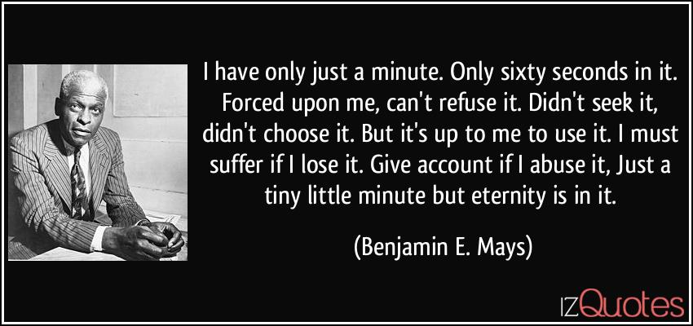
https://izquotes.com/quote/122101
Class requirements:
Paper, pencil, internet access
- Notes are required! You can take notes directly in Google Docs but will need to take a picture of math problems worked out.
- A graphing calculator is necessary for Algebra 2 Texas Instruments has provided an online app for free use of their graphing calculator Please check your Chromebook for the App. There are several online sites that have many features of the graphing calculator:
https://www.meta-calculator.com/
https://www.geogebra.org/graphing?lang=en
https://www.desmos.com/calculator
Class websites requiring login: (Write your username and password for each in Google Docs and share the document with me. A deduction will be taken from each assignment in which you cannot find your login information. )
Textbook: https://connected.mcgraw-hill.com/
ALEKS: https://www.aleks.com/
USATestPrep: https://www.usatestprep.com/
Mastery Connect: https://www.masteryconnect.com/

Communication:
Email address mkinsler@mccormick.k12.sc.us
Google Classroom!!! Many helpful videos are posted on Google Classroom in addition to assignments. Please access this as soon as possible! Parents can send me information to be invited to view the site.
I will use Remind as often as possible to remind students and alert parents of upcoming major assignments.
Classwork- Students are required to attend class either in person or virtually Monday through Thursday. You are expected to log in three to five minutes before class begins. You will be marked tardy if you are late. You will be marked absent if you are not there for most of the time. The class time will be spent teaching concepts, working examples, and practicing problems interactively.

Tests: Chapter tests will be taken Face to Face in class. Virtual students will be required to come to school on the Friday of test week.

Class rules:
All class rules are designed to allow each student to have the opportunity to maximize learning. School rules will be followed!
- Cell phones are to be put on silent or turned off and placed in the phone caddy at the beginning of class.
- Students are not to answer questions directed to another student.
- Raise your hand if you have a question.
- See the document in Google Classroom regarding virtual class.

Communication:
Email address mkinsler@mccormick.k12.sc.us
Google Classroom!!! Many helpful videos are posted on Google Classroom in addition to assignments. Please access this as soon as possible! Parents can send me information to be invited to view the site.
I will use Remind as often as possible to remind students and alert parents of upcoming major assignments.

Class requirements:
Paper, pencil, charged chrome book, internet access
- Notes are required! You can take notes directly in Google Docs but will need to take a picture of math problems worked out.
- A graphing calculator is necessary for Algebra 2 Texas Instruments has provided an online app for free use of their graphing calculator Please check your Chromebook for the App. There are several online sites that have many features of the graphing calculator:
https://www.meta-calculator.com/
https://www.geogebra.org/graphing?lang=en
https://www.desmos.com/calculator
Communication:
Email address mkinsler@mccormick.k12.sc.us
Google Classroom!!! Many helpful videos are posted on Google Classroom in addition to assignments. Please access this as soon as possible! Parents can send me information to be invited to view the site.
I will use Remind as often as possible to remind students and alert parents of upcoming major assignments.
Classwork- Students are required to attend class either in person or virtually Monday through Thursday. You are expected to log in three to five minutes before class begins. You will be marked tardy if you are late. You will be marked absent if you are not there for most of the time. The class time will be spent teaching concepts, working examples, and practicing problems interactively.

Tests: Chapter tests will be taken Face to Face in class. Virtual students will be required to come to school on the Friday of test week.
Grades – Grades are categorized as Major or Minor. Chapter tests and Quarterly Notebook grades carry major weight. All other grades such as homework and classwork are minor. Major grades are 60% of the quarter grade. Minor grades are 40% of the quarter grade. A midterm exam will be given at the end of the first quarter. It will be counted as a test grade. A final exam will be given at the end of the semester. The course grade is calculated by averaging the two quarters and the final exam. Each quarter is valued at 40% of the course grade. The exam is 20% of the course grade.
Retest opportunity: Students have two opportunities to take another test to replace a test grade provided the student takes the initial test during the time it is originally administered.
Chapter 0 – The concepts presented are review from previous courses. They will reinforce prerequisite skills. The mastery of these skills is necessary for the success in the course. Some students may not need the review while other students may need more than the work assigned.
First Quarter:
Chapter 1 – Definitions, postulates, logical reasoning, and theorems are tools used to develop an awareness of the structure of mathematical systems, prove geometric relationships, and solve problems. Constructions are used to explore attributes of geometric figures. Points, lines, rays, line segments, and figures can be represented on one- and two-dimensional coordinate systems. Essential question: Why do we measure?
Chapter 2 – Mathematical reasoning uses observations to formulate conjectures. Logical reasoning is used to prove statements that are true and find counterexamples to disprove statements that are false. Conditional statements and their related conditionals have a truth value that can be determined using logical reasoning. Deductive reasoning uses facts, rules, definitions, or properties to reach logical conclusions. Essential question: Why is it important to be able to think logically?
Chapter 3 – A congruence transformation is a transformation in which the position of the image may differ from the preimage, but the two figures are congruent. Congruence transformations can be used to make conjectures and justify properties in geometry. Essential questions: Where can transformations be found? Why is symmetry desirable?
Chapter 4 – Triangles can be classified based on their angle measures or their number of congruent sides. The Angle Sum Theorem states that the sum of the measures of the interior angles of a triangle is always 180. This theorem and the definition of congruence can be used to develop other theorems and postulates about triangle congruence. The coordinate plane can be used in combination with algebra to write coordinate proofs. Essential questions: How can you compare two objects? How can you tell if two objects are congruent? How can you tell if two triangles are congruent?
Chapter 5 – Perpendicular bisectors, angle bisectors, medians, and altitudes are special segments of triangles that can be used to investigate geometric relationships. Inequalities in one and two triangles can help classify and solve unknown triangles. Essential questions: What makes a triangle a triangle? How are the sides and angles of a triangle related?
Chapter 6 – The Interior Angles Sum Theorem can be used to find the sum of the interior angles of a polygon or the measure of each interior angle in a regular polygon. Parallelograms, rectangles, rhombi, squares, trapezoids, and kites are all quadrilaterals that have special properties that can be used to identify them. Essential question: Why do we name figures?
Second Quarter
Chapter 7 – A ratio is a comparison of two quantities and can be used to solve problems involving similar figures. Similar figures are related by a scale factor that is the ratio of the lengths of two corresponding sides. Similar triangles can be used to measure distances indirectly. If two figures are similar, there is a relationship between the perimeters of similar polygons and the altitudes, medians, and bisectors of similar triangles. Essential questions: How can two objects be similar? How does similarity in mathematics compare to similarity in everyday life?
Chapter 8 – Similarity properties can be used to explore and justify conjectures about geometric figures. The Pythagorean Theorem is used to solve right triangles and prove that given measures form right triangles. Trigonometric ratios can be used to solve right triangles and meaningful problems like angles of elevation and depression. Essential question: Why do we use mathematics to model real-world situations?

Chapter 9 – A circle is the focus of all points equidistant from a given point. Chords, diameters, and radii are all segments associated with circles. Proportional reasoning is used to find the areas of sectors and arc lengths of circles. Essential question: How can circles be used?
Chapter 10 – The formulas for the areas of parallelograms, triangles, trapezoids, rhombi and kites are developed from the definitions and properties of the polygons. The properties of circles and regular polygons are used to find the areas of inscribed and circumscribed polygons. Essential question: How can decomposing and recomposing shapes help us build our understanding of mathematics?
Chapter 11 – The surface area and volume of prisms, pyramids, spheres, cones, cylinders, and composites of these figures are given by formulas which can be used to solve problems. When one or more dimensions of a figure are changed, the corresponding change in volume and area can be calculated using the formulas for each figure. Essential question: How are two-dimensional and three-dimensional figures related?
Chapter 12 – A sample space of an experiment is the set of all possible outcomes. The probabilities of independent, dependent, mutually exclusive, not mutually exclusive, and conditional events can be calculated. Geometric probabilities. Like the probability of hitting a target, can be calculated using the area. Probability can be determined using the Multiplication Rule, the Addition Rule, or two-way frequency tables. Essential questions: How can we predict the outcomes of events? How can we quantify predictions?
Pacing Guide:
Chapter | Title | Number of Days
0 | Preparing for Geometry | 3
1 | Tools of Geometry | 8
2 | Logical Arguments and Line Relationships | 9
3 | Rigid Transformations and Symmetry | 6
4 | Triangles and Congruence | 6
5 | Relationships in Triangles | 6
6 | Quadrilaterals | 5
7 | Similarity | 5
8 | Right Triangles and Trigonometry | 6
9 | Circles | 6
10 | Extending Area | 7
11 | Extending Volume | 7
12 | Probability | 5

